Home Page — IDGen
URL: /

H1

Identity Solutions Simplified

Custom ID Cards, Printed Lanyards & Complete Identification Solutions for Schools, Companies, Institutions & Events
IDGen is a Guwahati-based identity solutions company helping organizations across Assam and Northeast India create professional identification systems—from ID card printing and custom lanyards to RFID cards, event badges, ID card accessories, and digital data collection through IDGen Studio.
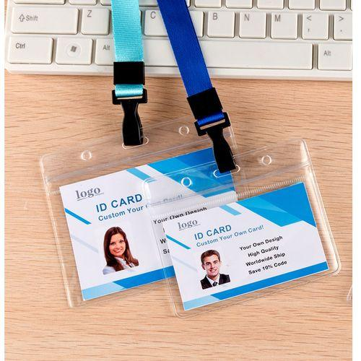
10,000+ IDs/day capacity*
72-hour dispatch
Guwahati • Assam
Complete ID Solutions
Cards, lanyards, holders, hooks & RFID in one workflow.
Preview Before Printing
Reduce errors with data review and approval.
*Production capacity depends on product type, personalization, quantity and project requirements.

Trusted by Organizations That Need More Than Just an ID Card
Most organizations don't simply need a card—they need a complete identification system.
Whether you're onboarding 2,000 students, issuing employee ID cards, organizing a conference, or replacing annual ID cards, IDGen helps coordinate the entire workflow from data collection to finished wearable identification.

One workflow. One partner.

Our Identity Services
IDGen provides specialized identification services designed for institutions and organizations.
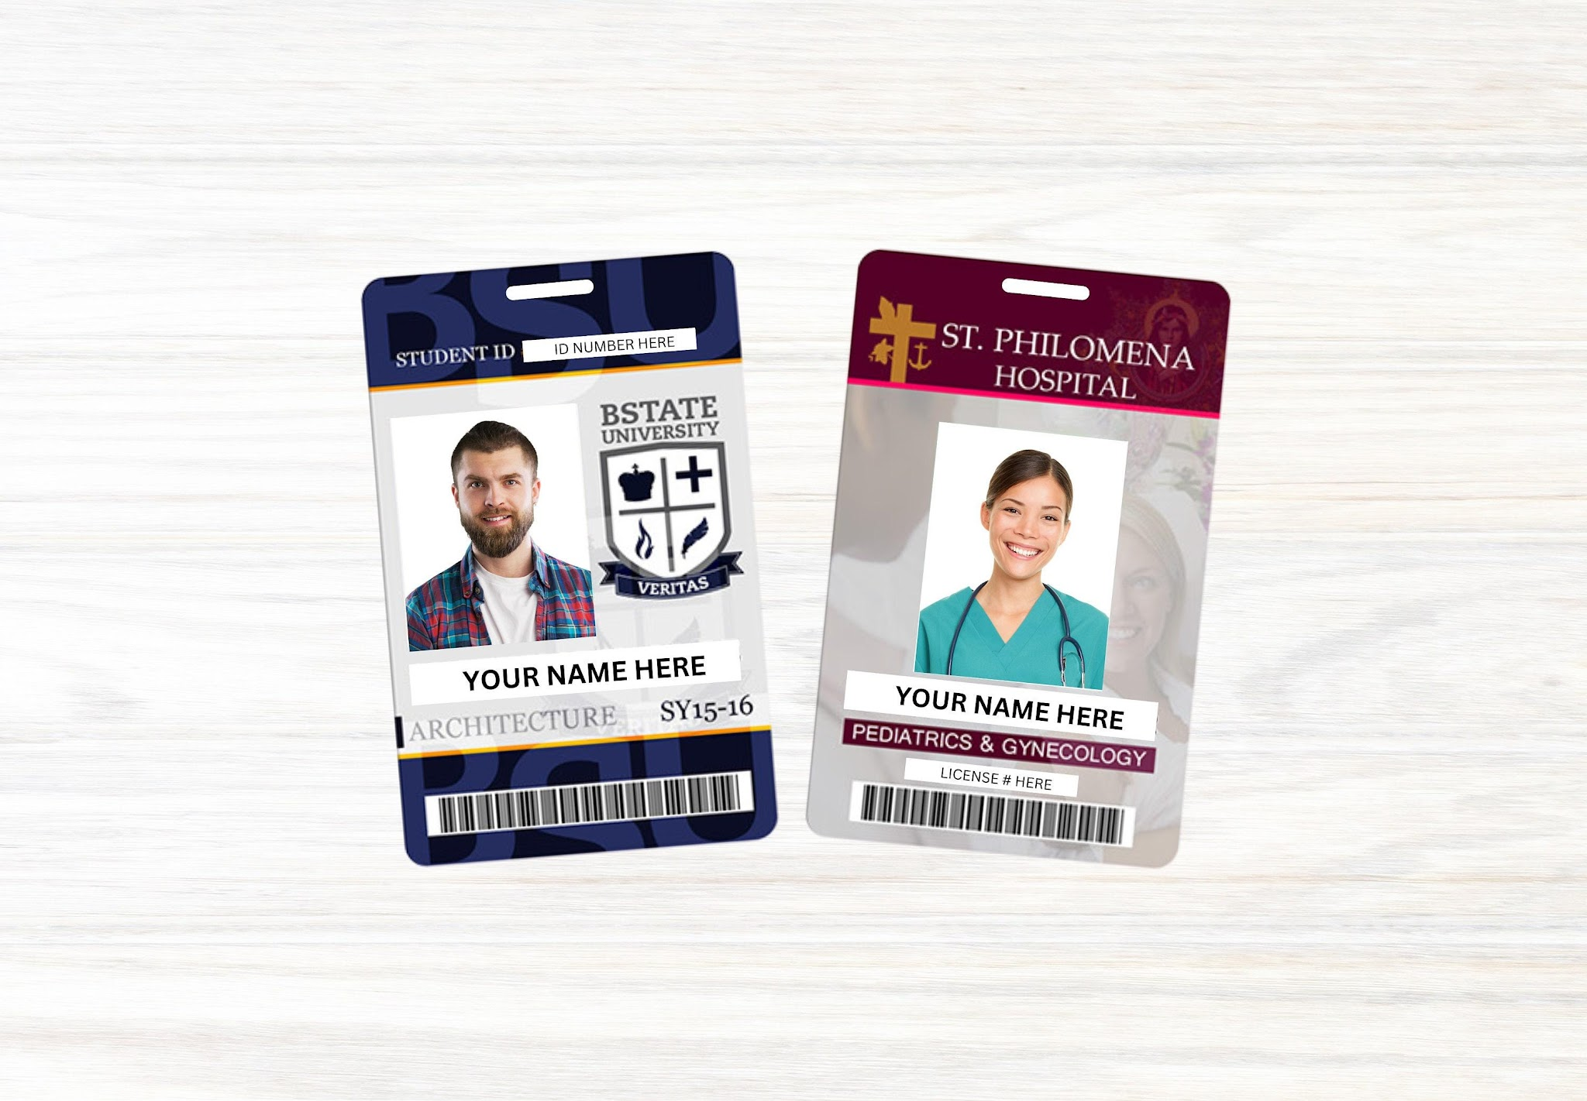
ID Card Printing
PVC ID cards for schools, colleges, companies, hospitals and institutions.
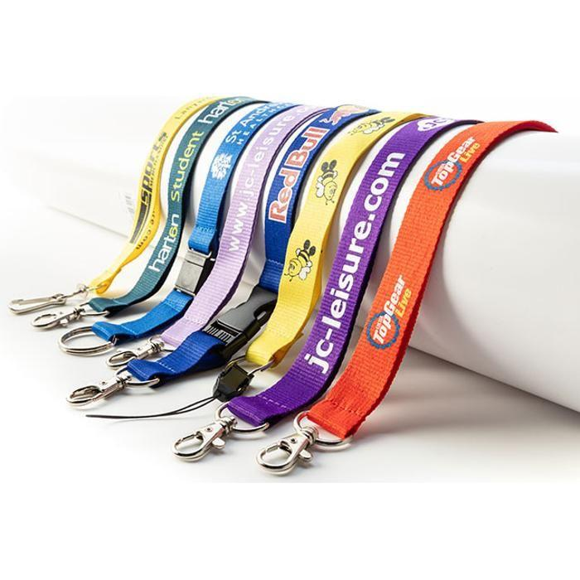
Custom Printed Lanyards
Branded 20 mm lanyards with logos, colors and custom artwork.
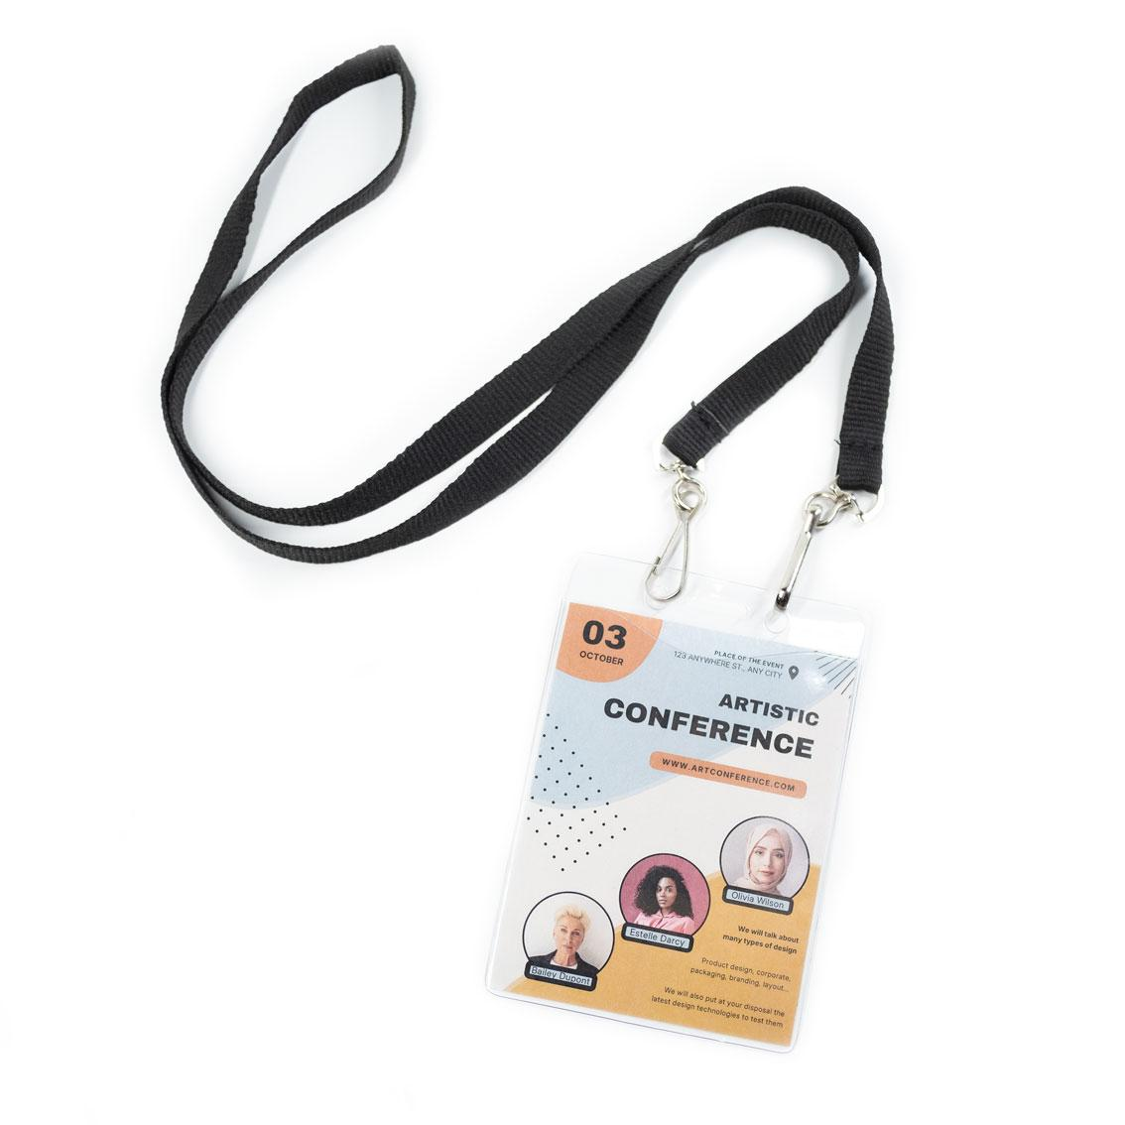
Event Card Printing
Conference badges, delegate cards and event identification solutions.

RFID Card Printing
Customized RFID cards compatible with attendance and access systems.
Internal links: /id-card-printing/, /custom-printed-lanyard-printing/, /event-card-printing/, /rfid-card-printing/

Complete Identification Solutions
Most customers don't order individual products—they order a complete wearable identification system.
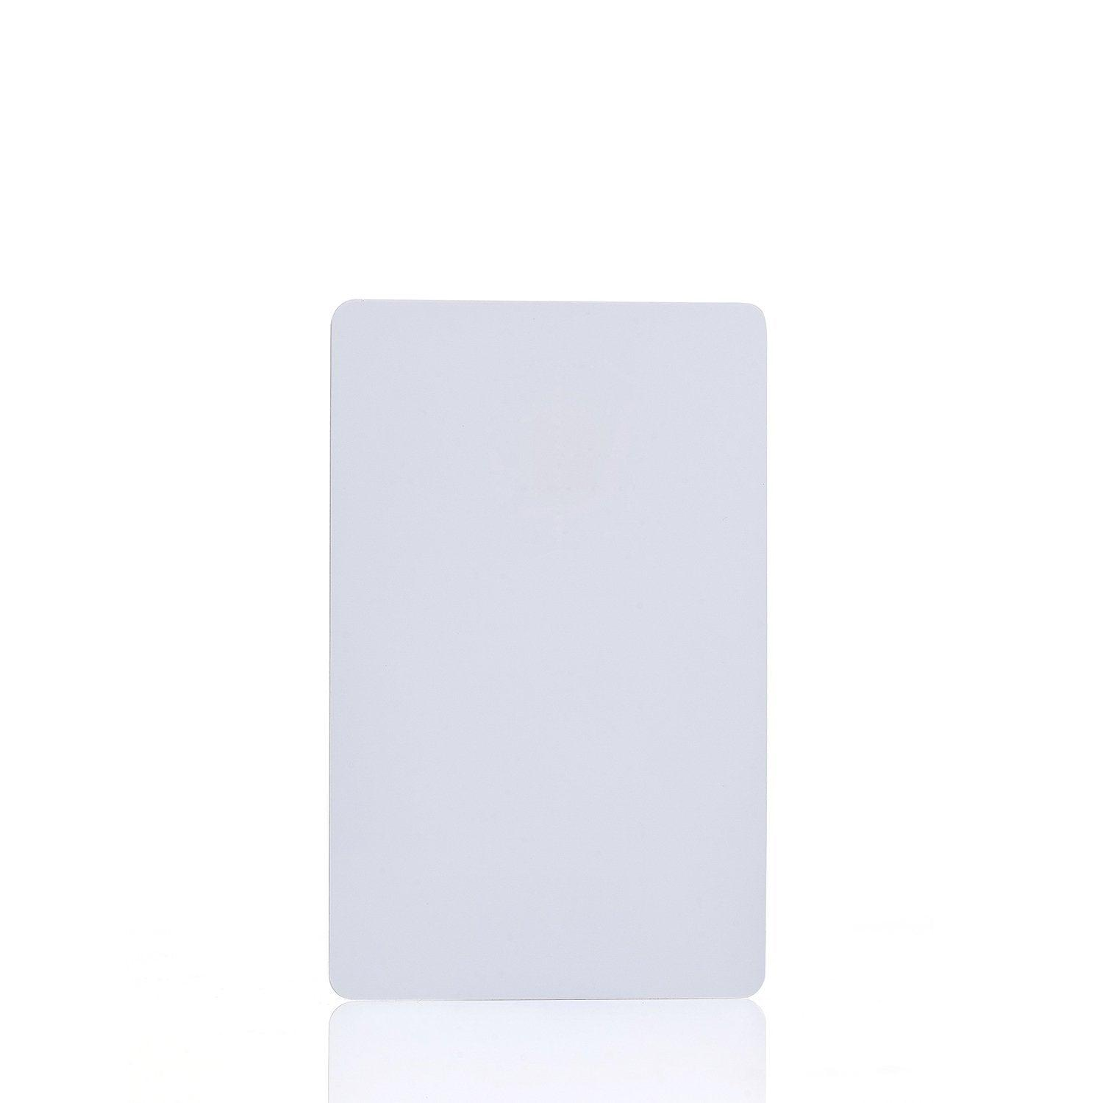
Card Only
Suitable when your organization already has holders and lanyards.
Card + Holder
Protects the card while keeping it professional and durable.
Wearable Identification
Card + Holder + Hook + Lanyard for daily student and employee use.
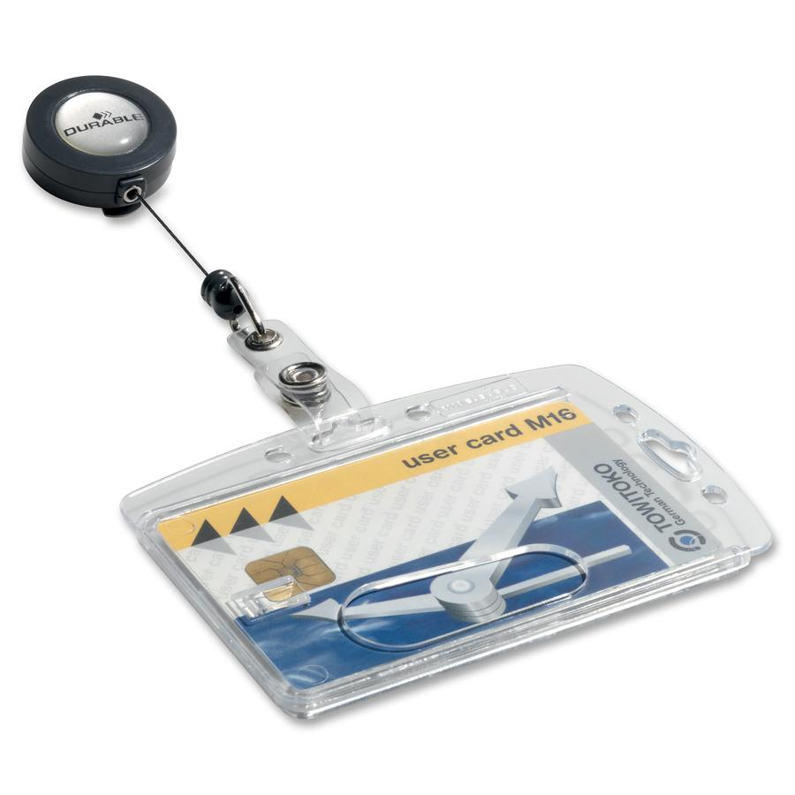
Complete Ready-to-Use Set
Ultrasonic sealing + holder + hook + lanyard for a finished wearable solution.

Solutions for Every Organization
Instead of creating separate product pages for every customer type, IDGen builds solutions around how organizations actually use identification.
Students
School, college and university identification with bulk personalization.
Companies
Employee, staff and visitor identification with branded accessories.
Events
Conference badges, delegate cards and one- or two-hook lanyard configurations.
Institutions
Hospitals, NGOs, government organizations and membership programmes.
Internal links: /student-id-card-printing/, /employee-id-card-printing/, /event-card-printing/

IDGen Studio — Digital Identity Workflow
Collecting photographs and personal information is often the most difficult part of an ID card project.
IDGen Studio connects digital data collection with physical ID card production.
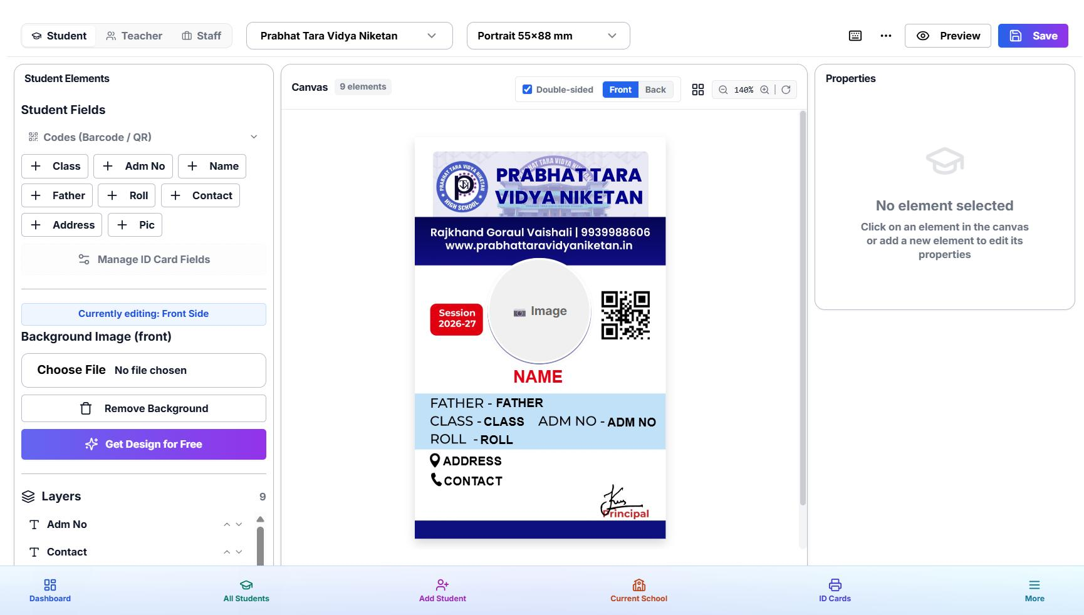
Digital Data Collection
Collect names, photographs and ID information in one workflow.
Photo Management
Keep photographs connected to the correct student or employee record.
Card Preview
Review personalized cards before production begins.
Approval Workflow
Approve records before printing to reduce costly reprints.
See It Before We Print It.
Internal link: /idgen-studio/

Why Organizations Choose IDGen
Identity-Focused Business
Specialized in organizational identification systems.
Structured Workflow
Requirement → Preview → Production → Quality → Dispatch.
Bulk Capability
Designed for institutional and high-volume projects.
Complete ID Solutions
Cards, lanyards, holders, hooks and RFID in one workflow.
Preview Before Printing
Reduce data and personalization errors before production.
Guwahati-Based Service
Serving Assam and the wider Northeast India market.
Internal link: /why-idgen/

IDGen at a Glance
Based in Guwahati
Serving organizations across Assam and Northeast India.
Up to 10,000 IDs/Day
Production capability varies by product and project requirements.
72-Hour Dispatch
After approval and payment, subject to applicable order conditions.
Institutional Focus
Schools, colleges, companies, hospitals, NGOs and events.

Serving Assam & Northeast India
IDGen is based in Guwahati, Assam and provides identification solutions across Assam and the wider Northeast India region.
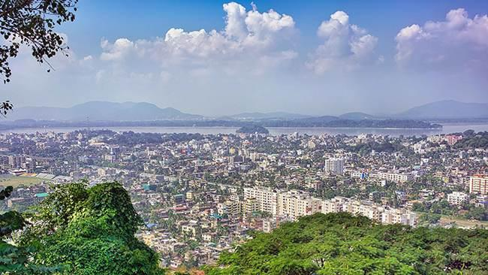
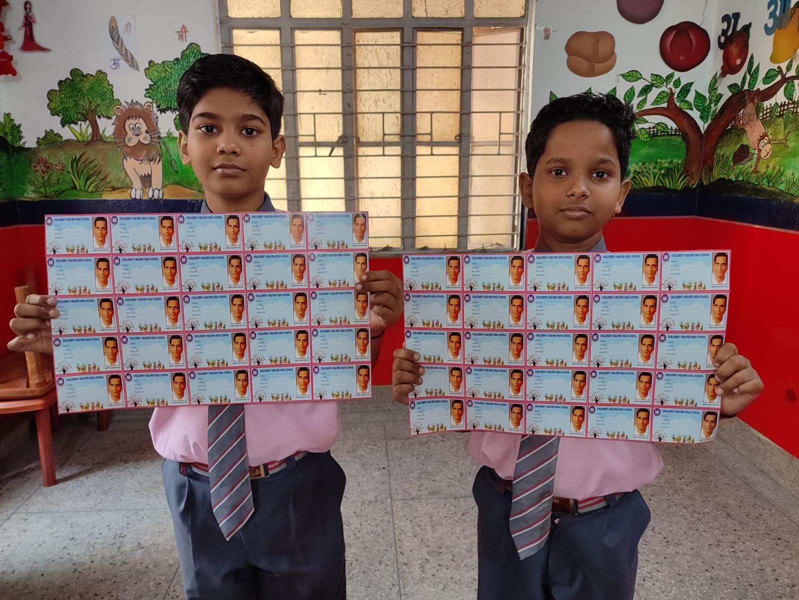
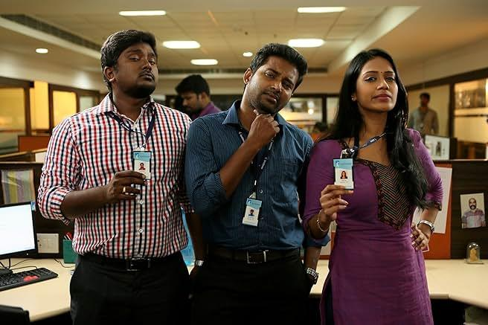
4

Priority Service Areas
- Guwahati
- Jorhat
- Dibrugarh
- Silchar
- Tezpur
- Nagaon
- Tinsukia
- Sivasagar
- Golaghat
- Barpeta
Internal links: /service-areas/assam/, /service-areas/assam/guwahati/

Frequently Asked Questions
What does IDGen do?
IDGen provides customized ID cards, printed lanyards, RFID cards, event badges, ID card accessories and digital identity workflows for organizations.
Where is IDGen located?
IDGen is based in Guwahati, Assam, and serves customers across Northeast India.
Can IDGen handle bulk ID card printing?
Yes. Bulk ID card printing is supported for schools, colleges, companies, institutions and events through the main ID card printing service.
Can I order a complete ID card set?
Yes. You can combine ID cards, holders, hooks, ultrasonic sealing and custom printed lanyards into one complete wearable identification solution.
Does IDGen provide data collection?
Yes. IDGen Studio supports digital data collection, photograph management, card preview and approval before printing.

Ready to Build Your Identification System?
Whether you need student ID cards, employee identification, RFID cards, event badges or complete wearable ID solutions, IDGen helps you coordinate the entire workflow from data to dispatch.

Tell us your requirement
We'll help you choose the right products, accessories and workflow for your organization.
Request a Quote
WhatsApp IDGen
Contact Our Team

SEO Package

URL
/

SEO Title
ID Card Printing & Identity Solutions in Guwahati | IDGen

Meta Description
IDGen provides ID card printing, custom lanyards, RFID cards, event badges and complete identity solutions for schools, colleges, companies and organizations across Assam and Northeast India.

Primary Keywords
- Identity solutions
- ID card printing
- Custom printed lanyards
- RFID card printing
- Event card printing
- ID card accessories
- Student ID cards
- Employee ID cards
- Guwahati
- Assam

Schema to Implement
- Organization
- LocalBusiness
- WebSite
- FAQPage
- BreadcrumbList

Homepage Media Checklist
Section | Media Recommendation
Hero | Real IDGen finished ID-card set photo
Intro | 30–60 sec workflow video
Services | Product photography (4 cards)
Complete Solutions | Assembly infographic
IDGen Studio | Software screenshot
Trust | Real team / finished orders
Location | Guwahati / Assam imagery

Content ownership (avoid duplication)
Topic | Owner Page
ID card printing | /id-card-printing/
Student solutions | /student-id-card-printing/
Employee solutions | /employee-id-card-printing/
Lanyard printing | /custom-printed-lanyard-printing/
Event cards | /event-card-printing/
RFID | /rfid-card-printing/
Ultrasonic sealing | /ultrasonic-sealing/
Trust & quality | /why-idgen/
Digital workflow | /idgen-studio/
Pricing | /pricing/
This homepage acts as the authority hub for the entire IDGen website rather than trying to rank for every keyword itself.
also mention what image file name and alt text i have to add in files
Absolutely. For IDGen, I would treat image filenames + ALT text + captions + placement as part of the SEO/GEO/AEO architecture, not as an afterthought.
For the homepage, don't use generic filenames such as:
IMG_1234.jpg
id-card-final.jpg
banner1.jpg
Use descriptive, human-readable filenames that match the image's actual subject.

Homepage Image SEO Plan
# | Homepage location | Recommended image | File name | ALT text | Caption / purpose
1 | Hero | Real IDGen ID card + lanyard + holder set | idgen-complete-id-card-identification-set.jpg | Complete ID card identification set with ID card, holder, hook and custom printed lanyard | IDGen complete identification solution
2 | Hero/intro | IDGen production / finished products | idgen-id-card-printing-identity-solutions-guwahati.jpg | IDGen identity products and ID card printing solutions in Guwahati | Identity solutions from IDGen
3 | Services — ID cards | Student/employee PVC cards | custom-pvc-id-card-printing-idgen.jpg | Custom PVC ID card printing by IDGen | Customized PVC identification cards
4 | Services — lanyards | Printed lanyards | custom-printed-id-card-lanyards-idgen.jpg | Custom printed ID card lanyards by IDGen | Branded 20 mm ID card lanyards
5 | Services — events | Event cards with lanyards | event-card-printing-lanyard-idgen.jpg | Custom event cards with printed lanyards by IDGen | Event identification solutions
6 | Services — RFID | RFID cards | rfid-card-printing-idgen.jpg | Customized RFID card printing by IDGen | RFID identification cards
7 | Complete identification | Card → holder → hook → lanyard | complete-id-card-set-card-holder-hook-lanyard.jpg | Complete ID card set with card holder hook and lanyard | Complete wearable identification
8 | Digital workflow | IDGen Studio dashboard | idgen-studio-id-card-data-collection.jpg | IDGen Studio digital ID card data collection and preview | Digital identity workflow
9 | Trust section | Actual IDGen production/team photo | idgen-identity-products-production-guwahati.jpg | IDGen identity product production and quality workflow in Guwahati | IDGen production and quality workflow
10 | Northeast section | Assam/Guwahati image | idgen-id-card-solutions-guwahati-assam.jpg | ID card and identity solutions by IDGen in Guwahati Assam | Serving Assam and Northeast India

One important point
Do not force keywords into ALT text.
For example, don't write:
best cheap ID card printing company Guwahati Assam student employee PVC RFID lanyard
That's poor accessibility and looks like keyword stuffing.
Instead:
Custom PVC ID card printing by IDGen
is much better.

Hero Image — Most Important
I would make your hero image a real IDGen photograph, not a stock image.

File
idgen-complete-id-card-identification-set.jpg

ALT
Complete ID card identification set with ID card, holder, hook and custom printed lanyard

Image title
IDGen Complete ID Card Identification Set

Caption
Complete identification solutions from IDGen
If possible, photograph your actual products professionally:
PVC ID Card + Holder + Hook + 20 mm Printed Lanyard
This gives Google/AI systems a much stronger connection between IDGen → identification products → physical business.

Services Section

ID Card Printing
File:
custom-pvc-id-card-printing-idgen.jpg
ALT:
Custom PVC ID card printing by IDGen
Don't use:
id-card-printing-guwahati-assam-cheap-best.jpg

Custom Lanyards
File:
custom-printed-id-card-lanyards-idgen.jpg
ALT:
Custom printed ID card lanyards by IDGen

Event Cards
File:
event-card-printing-lanyard-idgen.jpg
ALT:
Custom event cards with printed lanyards by IDGen
Remember that the event page should contain the detailed explanation of event-card configurations. The homepage only introduces it.

RFID
File:
rfid-card-printing-idgen.jpg
ALT:
Customized RFID card printing by IDGen
The detailed RFID information belongs on:
/rfid-card-printing/

Complete Identification Section
This is an important image for your website because it visually communicates one of IDGen's differentiators.

Photograph
Arrange:
ID Card → Holder → Hook → Lanyard
and, where appropriate, show the assembled version.

File
complete-id-card-set-card-holder-hook-lanyard.jpg

ALT
Complete ID card set with card holder hook and lanyard

Caption
Build your identification setup from card to complete wearable ID.
Then link to:
/id-card-printing/
and the appropriate accessory/service pages.

IDGen Studio
For this section, use an actual screenshot of your software rather than a generated stock image.

File
idgen-studio-id-card-data-collection.jpg

ALT
IDGen Studio digital ID card data collection and preview

Caption
Collect, review and prepare identification data before printing.
Link:
/idgen-studio/
This is particularly useful for your GEO/AEO strategy, because you're establishing a clear relationship:
IDGen → physical identification → digital identity workflow

Trust / Production Image
I strongly recommend using real photographs from your business here.
If you don't want machinery visible, don't photograph machinery. You can photograph:
- Finished cards
- Packed orders
- Lanyards
- Card sets
- Staff checking products
- Quality checking
- Finished bulk orders
- Packaging

File
idgen-identity-products-production-guwahati.jpg

ALT
IDGen identity product production and quality workflow in Guwahati
This is much more valuable for trust than a generic factory photograph.

Assam / Guwahati Section
You can use a location image, but don't use a generic Guwahati image as if it proves your business is there.
Better:
Real IDGen office + subtle Guwahati context

File
idgen-identity-solutions-guwahati-assam.jpg

ALT
IDGen identity solutions in Guwahati Assam
Caption:
Guwahati-based identity solutions serving organizations across Assam and Northeast India.
Then link to:
/service-areas/assam/
and
/service-areas/assam/guwahati/

Video SEO
I would also add one short real video to the homepage.
Don't create a generic promotional video just for SEO.
Make something like:

30–60 Second IDGen Workflow Video
Show:
Customer Data → Card Design → Preview → Printing → Lanyard → Assembly → Quality Check → Finished Order

Suggested video filename
idgen-id-card-printing-production-process.mp4

Video title
IDGen ID Card Printing & Identification Production Process

Video description
See how IDGen manages organizational identification projects from data and design through preview, production, quality checking and finished identification sets.
This can become useful supporting content for your Why IDGen and ID card printing pages too—but don't embed the exact same video everywhere unless it genuinely adds value.

Very Important: Don't Reuse the Same Image Everywhere
This is one of the changes I'd make to your previous website strategy.
For example, don't take:
custom-pvc-id-card-printing-idgen.jpg
and put it on:
- Homepage
- ID card printing
- Student ID card
- Employee ID card
- Pricing
- Why IDGen
- Guwahati
Instead, create different photographs for different search intents.

Example
Homepage
idgen-complete-id-card-identification-set.jpg
ID Card Printing
bulk-pvc-id-card-printing-idgen.jpg
Student ID
student-id-card-printing-schools-colleges-idgen.jpg
Employee ID
employee-id-card-printing-idgen.jpg
Lanyard
custom-printed-lanyard-idgen.jpg
This creates a much richer image/content ecosystem.

Your Image Naming System
I recommend adopting this standard across the entire IDGen website:
[subject]-[service/product]-[brand].jpg
Examples:
student-id-card-printing-idgen.jpg
bulk-pvc-id-card-printing-idgen.jpg
employee-id-card-printing-idgen.jpg
custom-printed-lanyard-idgen.jpg
event-card-printing-idgen.jpg
rfid-card-printing-idgen.jpg
ultrasonic-sealing-id-card-lanyard-idgen.jpg
id-card-holder-idgen.jpg
id-card-hook-idgen.jpg
complete-id-card-set-idgen.jpg
idgen-studio-data-collection.jpg
For local images:
id-card-printing-guwahati-idgen.jpg
student-id-card-printing-assam-idgen.jpg
id-card-solutions-guwahati-assam-idgen.jpg
But only use location in the filename when the image genuinely represents that location or the service is specifically being presented for that location.

Homepage: Final Media Structure
I would keep the homepage relatively visual but not overloaded:
Hero
→ 1 strong real product image
Services
→ 4 service/product images
Complete ID Solution
→ 1 assembly photograph/diagram
IDGen Studio
→ 1 real software screenshot
Why IDGen
→ 1 real business/production photograph
Assam/Northeast
→ 1 genuine location/business photograph or map graphic
Workflow Video
→ 1 short real IDGen video
So roughly 8–10 meaningful visual assets, rather than 20–30 random images.

And one more SEO rule
For every image, keep these aligned:
Image subject → filename → ALT → surrounding heading → nearby text → destination page
That creates a much stronger semantic signal than simply stuffing keywords into ALT attributes.
For the next page, /id-card-printing/, I'll keep this same system: complete page content + SEO/GEO/AEO + exact image placements + image filename + ALT text + suggested photo/video + internal links, while making sure content owned by /student-id-card-printing/, /employee-id-card-printing/, /pricing/, etc. is not duplicated.

